Creating IAM user “Jane” from root account with AdministratorAccess.
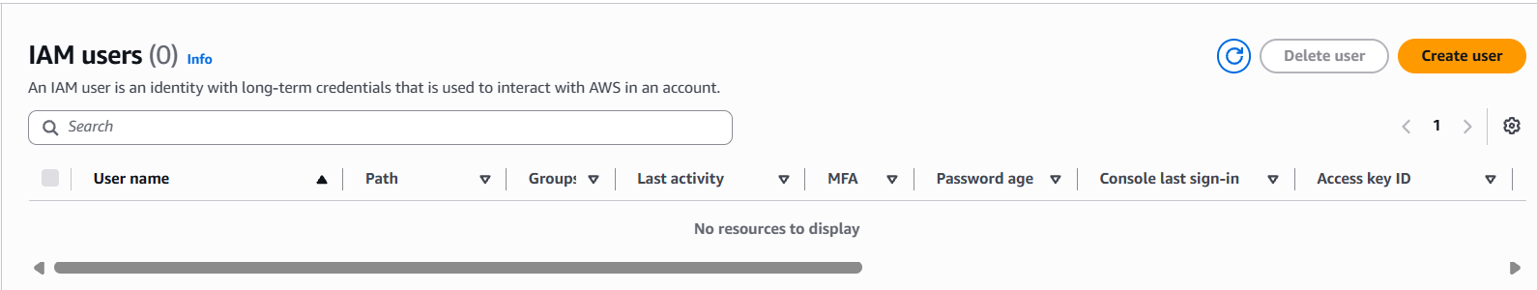
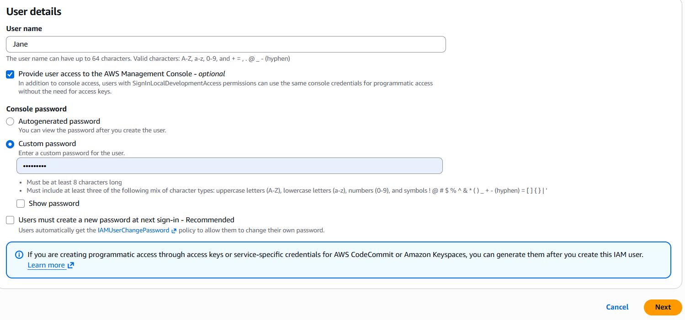
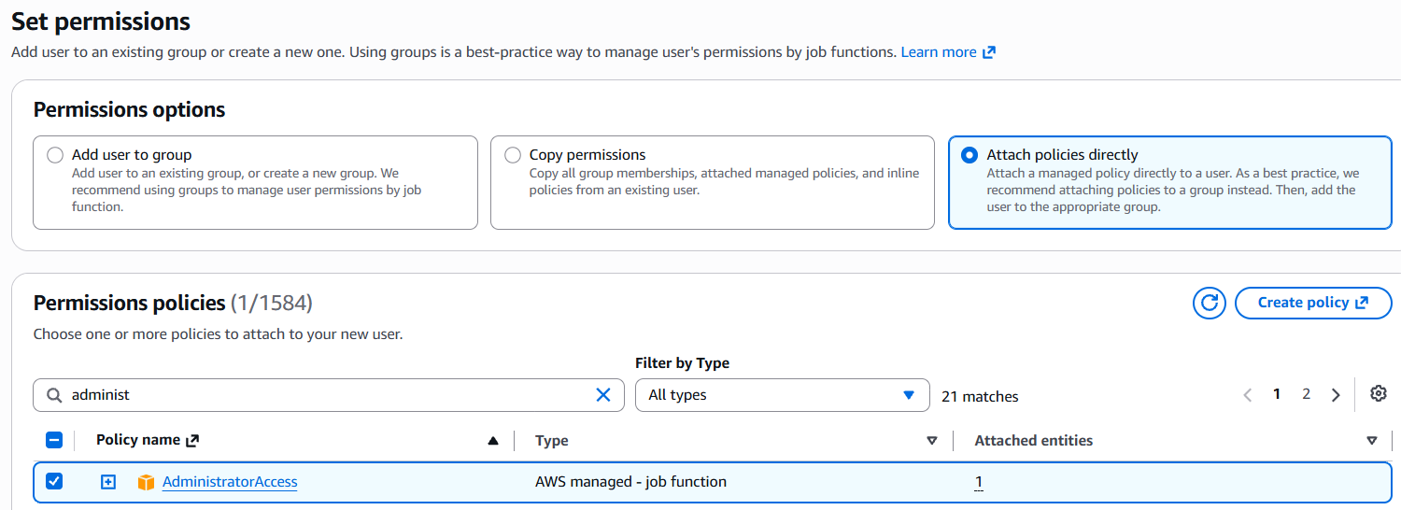
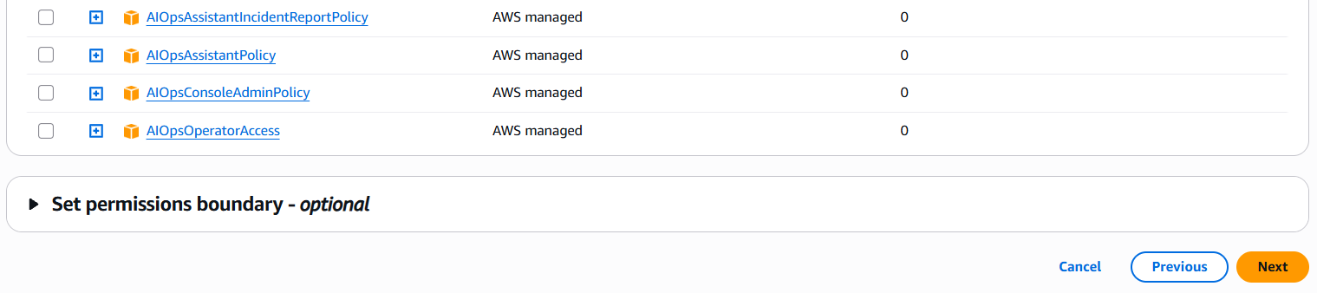

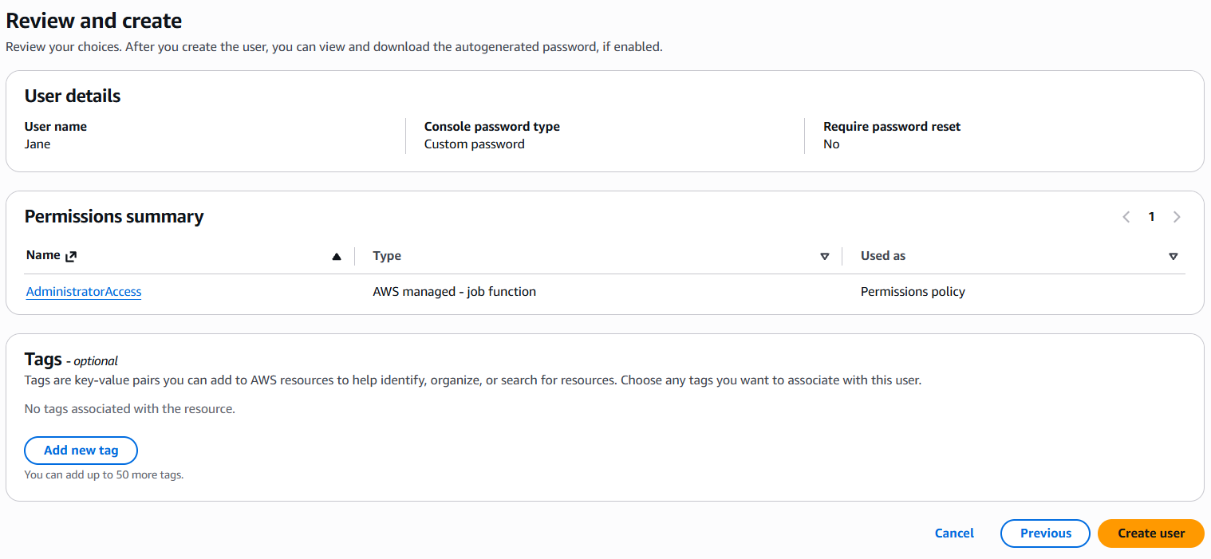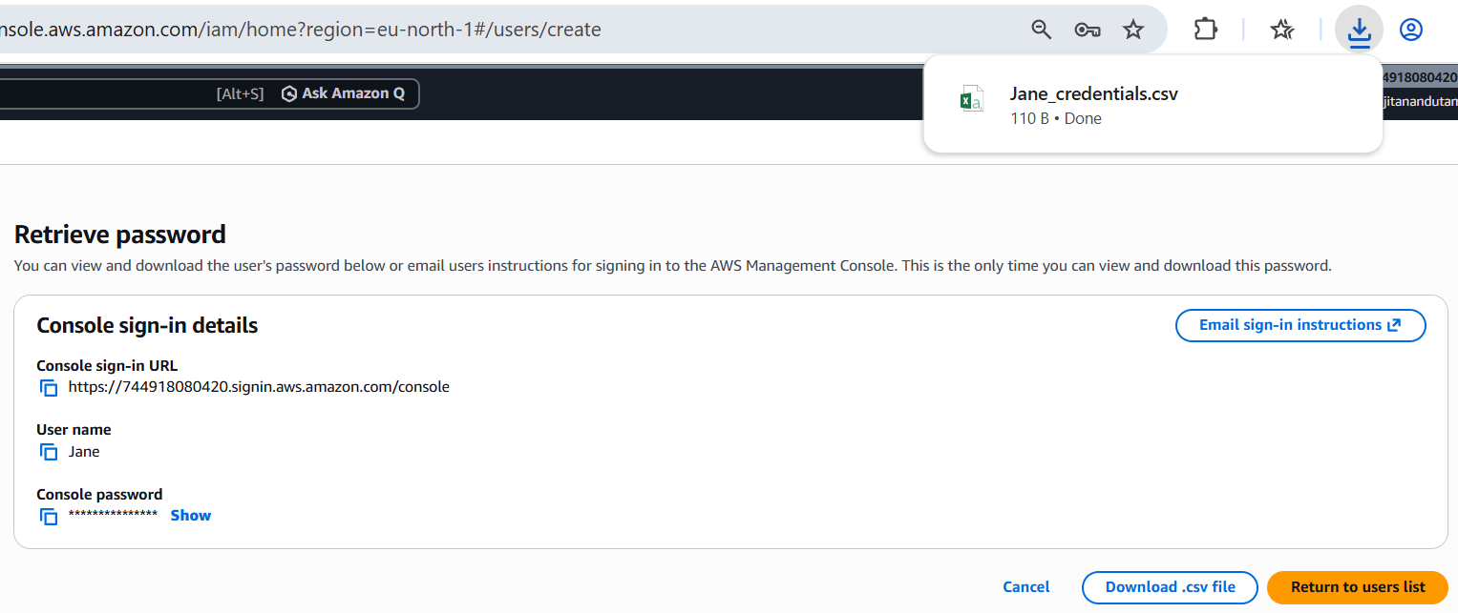
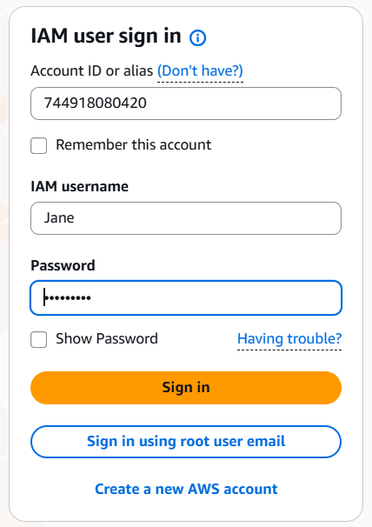
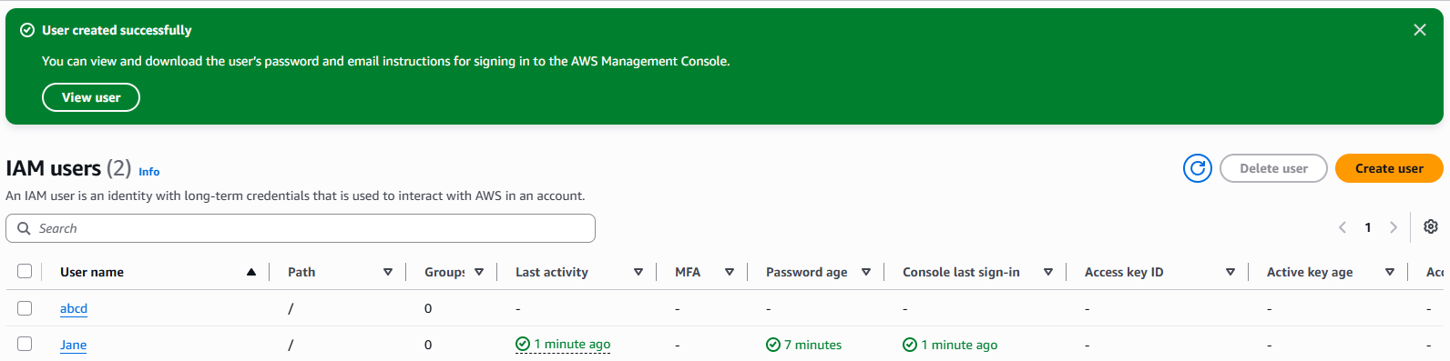
New user created “abcd” successfully.

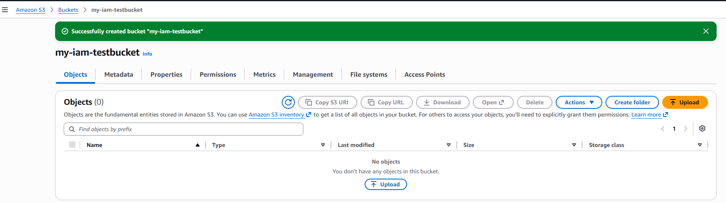
“my-iam-testbucket” created successfully in S3.
-----------------------------------------------------------------------------------------------------------------------------------------------------------
Creating IAM user “Susan” from root account with PowerUserAccess.
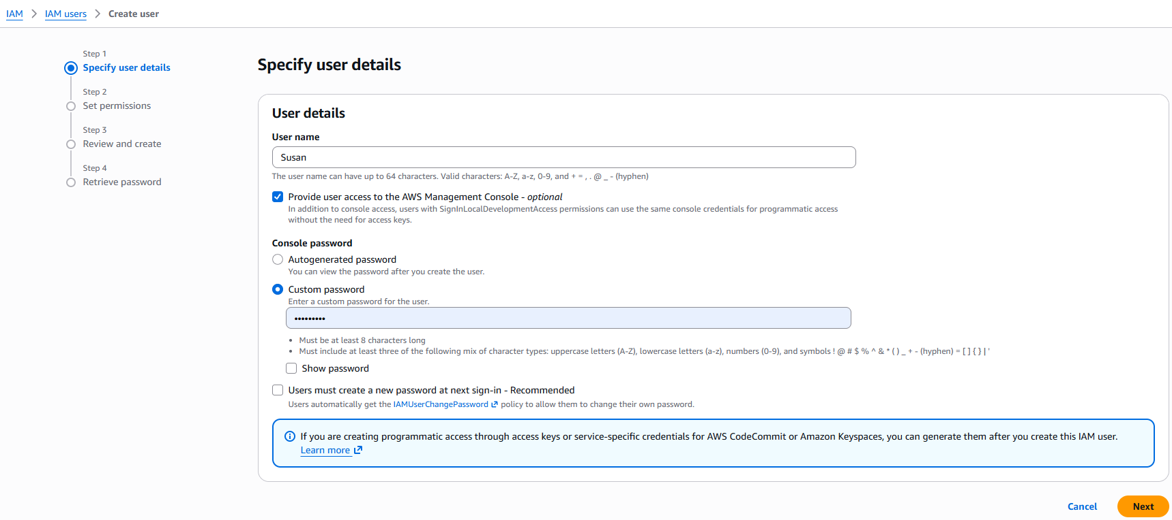
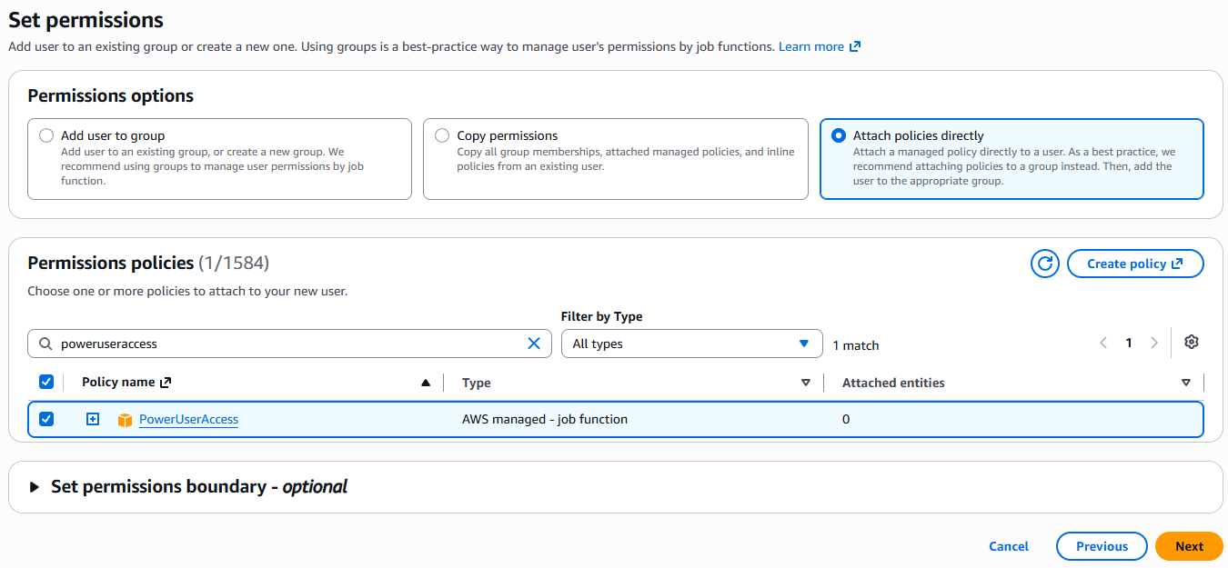
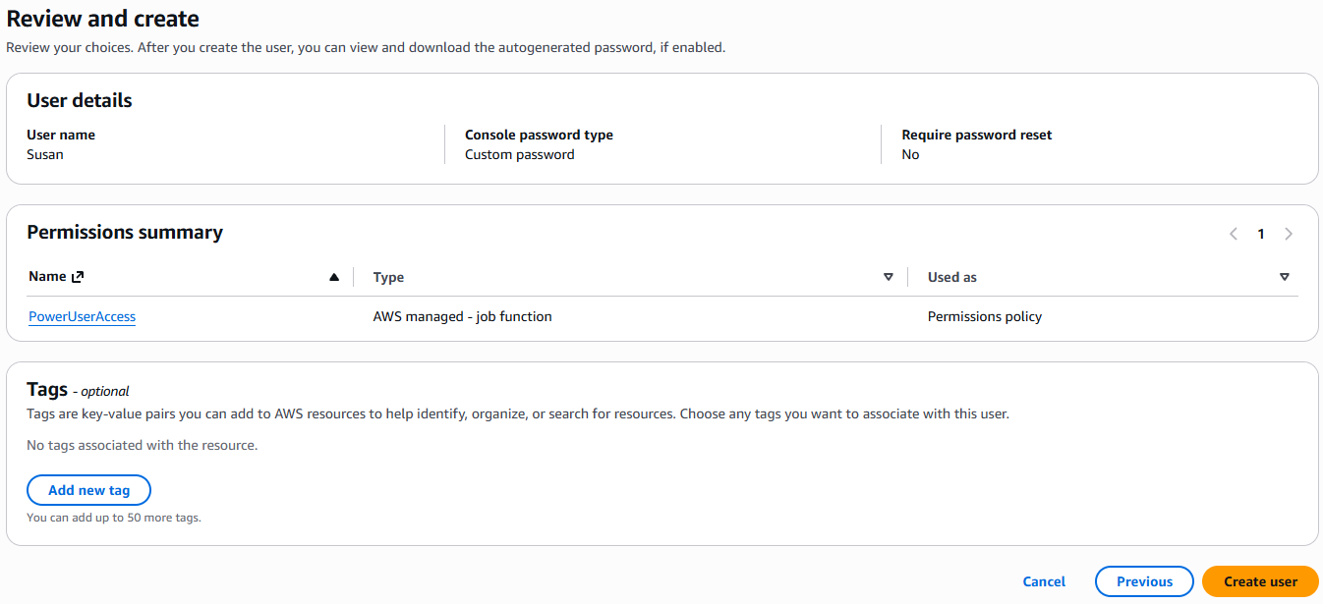
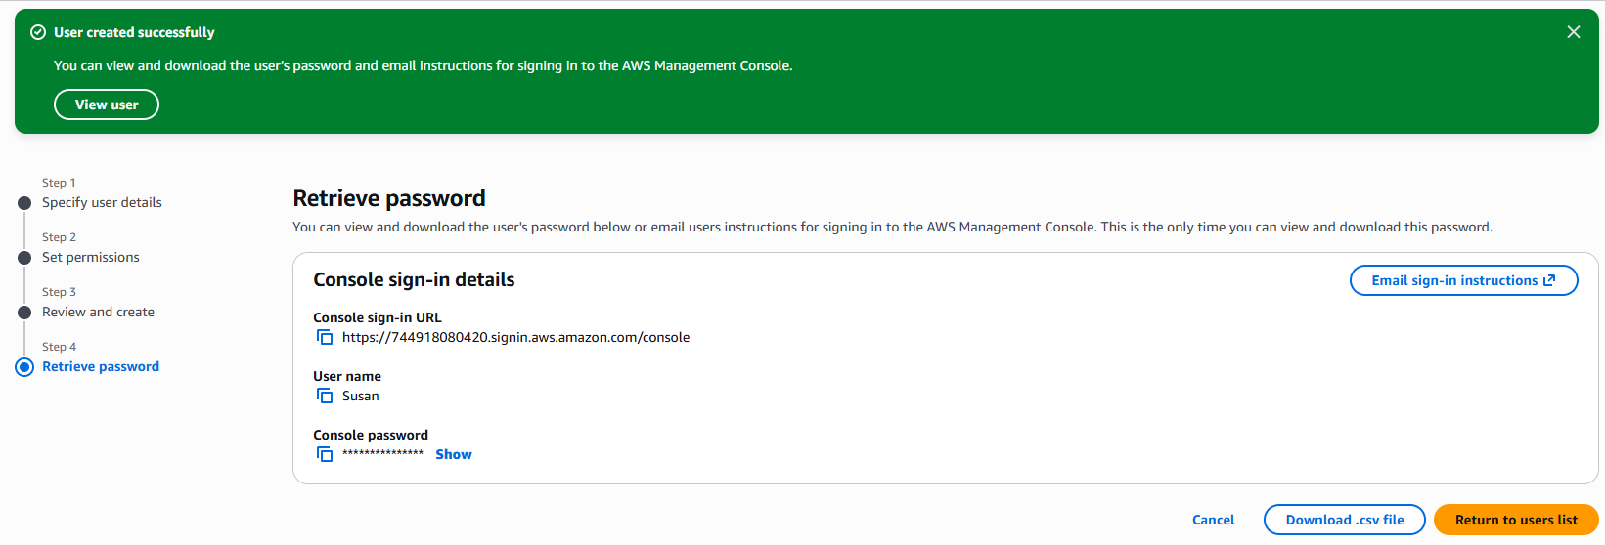
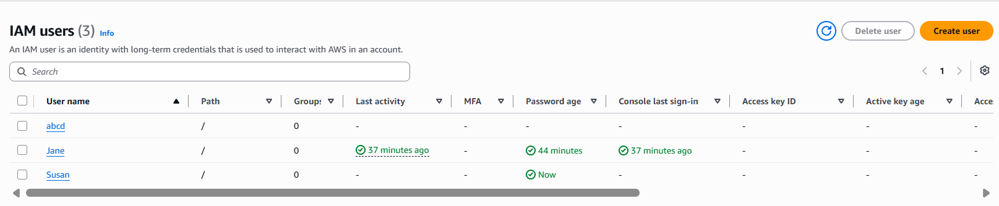
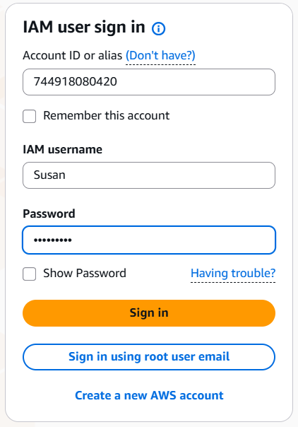s
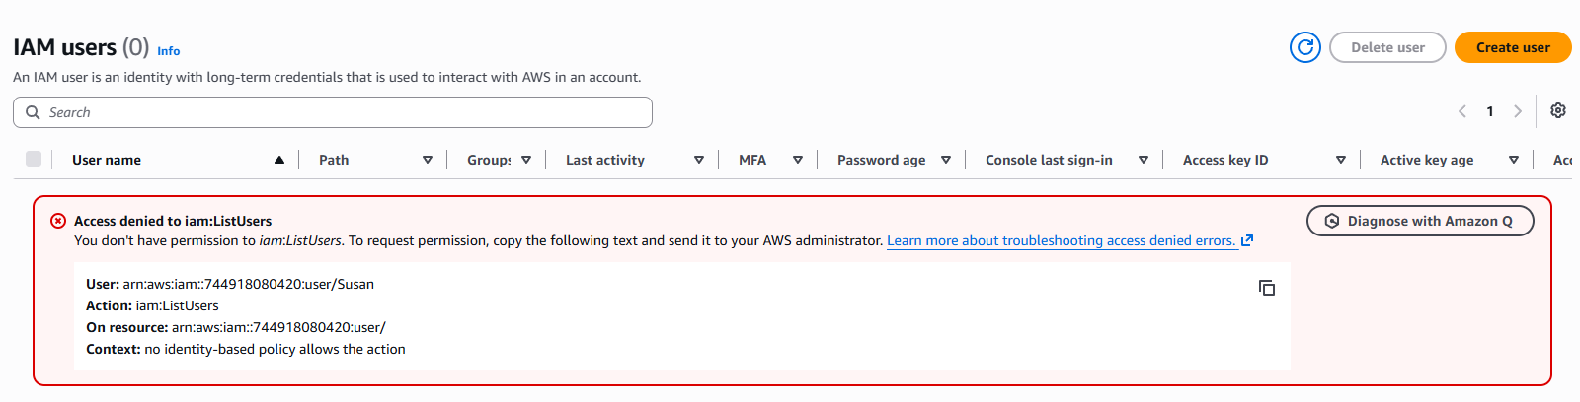
Unable to create a new IAM user due to the permission restrictions associated with the PowerUserAccess policy attached to the existing IAM user - Susan.

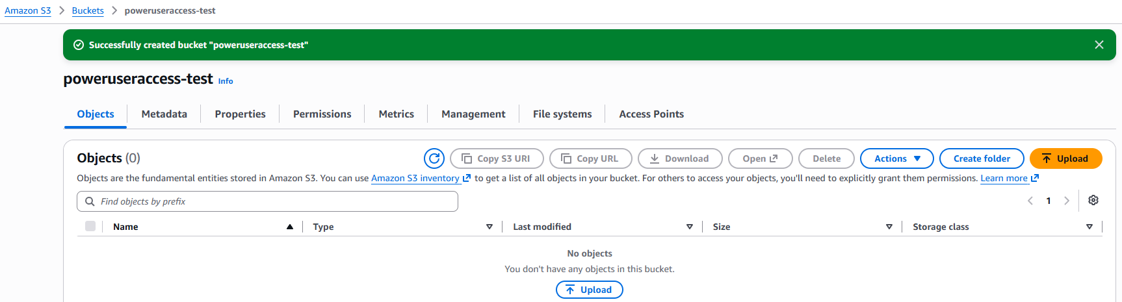
“poweruseraccess-test” created successfully in S3.

